Misael Herrera Barreto

Repositorio GIT: <https://github.com/MisaelHerreraB/retoQDS>

**Ejemplos**

[ [1,2], [3,4] ]

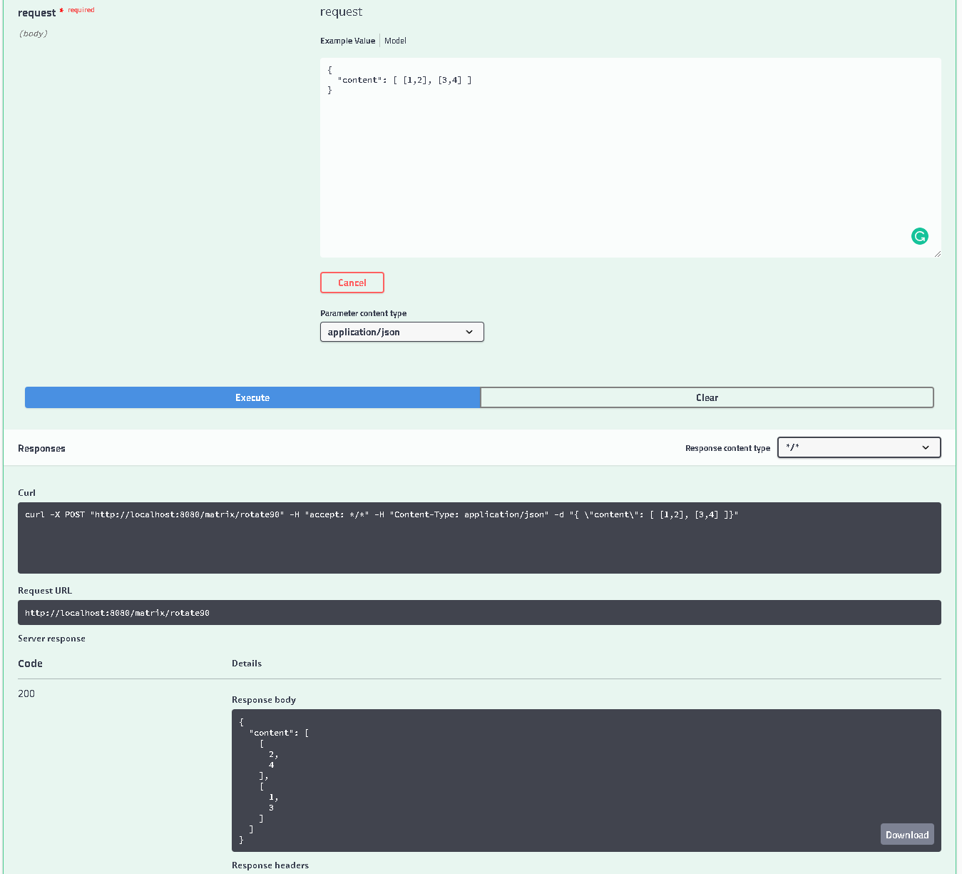

[ [1,2,3], [4,5,6], [7,8,9] ]

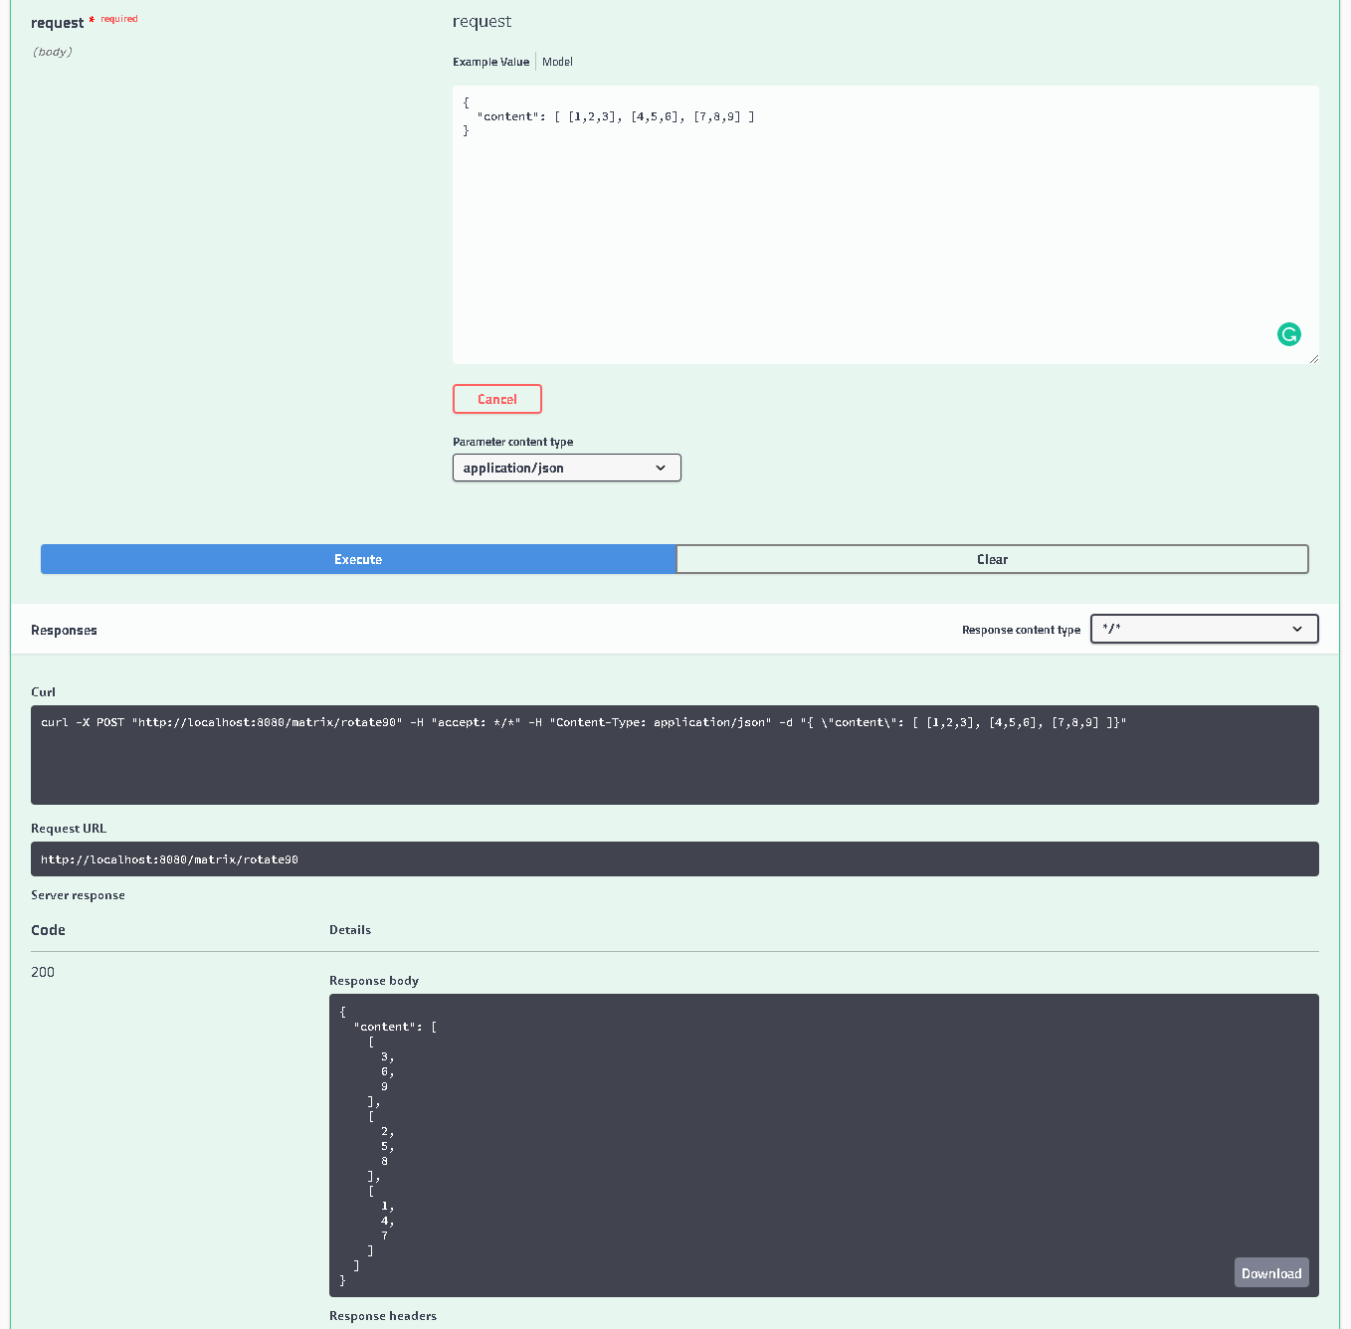

[]

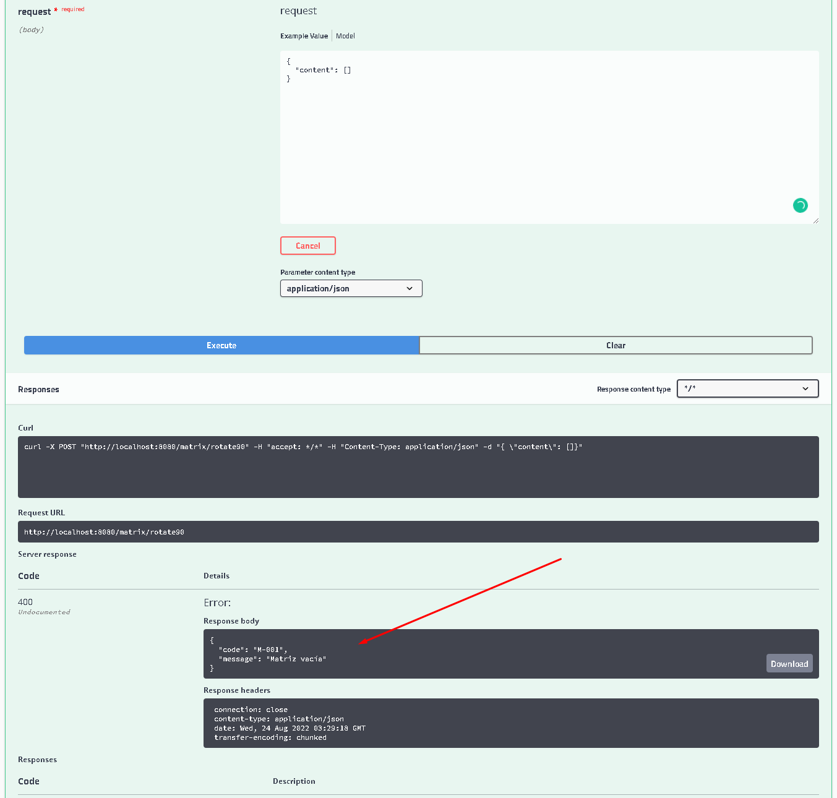

DOCKER

